# Momentum Strategies

## Problem Statement

Analyse the return characteristics of continuous momentum strategy portfolios with information discreteness signal and different risk approaches

## Methodology

Nifty 50 taken as benchmark and daily return considered from Jan 2005 to Dec 2016. A basket of large cap stocks is created which contains 170 scrips with daily returns in the same period.

Daily returns are aggregated at monthly level and monthly returns and past 12 month’s returns are calculated. The information discreteness of the past 12 months is calculated as

ID = sign(last 12 month return) * (#negative months - #positive months)

### Cross-sectional momentum

Stocks are ranked by their past 12 months returns and top 10 and bottom 10 are taken. They are further screened by their ID and 3 top performing and 3 bottom performing stocks are selected.

Portfolios are constructed in the following ways:

1. Long top 3 stocks with equal weights
2. Long top 3 stocks with risk parity
3. Market neutral with top 3 and bottom 3 with equally weighted long and short
4. Long top 3 and short bottom 3 with a risk budget of 10%
5. Long top 3 with risk budget of 10%

### Time-series momentum

The portfolio pivots between risky asset and cash depending on whether the 200SMA of the benchmark index is below or above the index value

## Assumptions

* Zero transaction costs and taxes
* Portfolio can be rebalanced at the beginning of every month at closing prices with sufficient liquidity

## Results

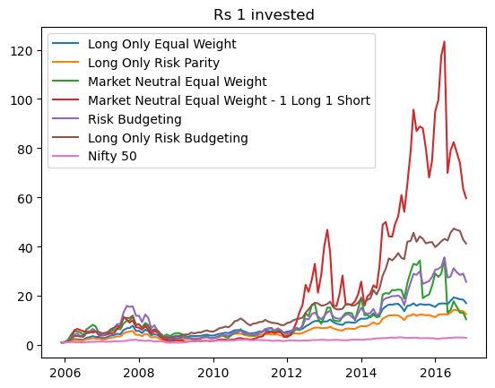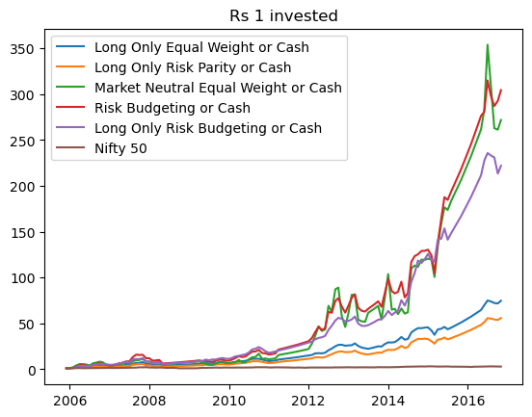

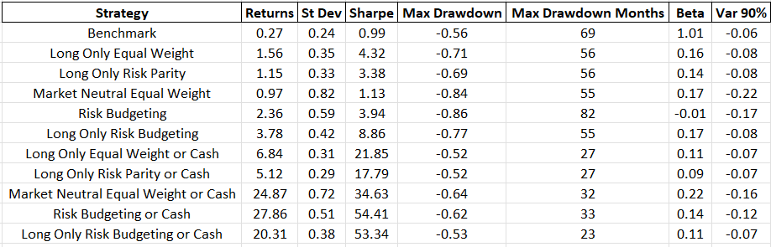

Code Repository : [GitHub](https://d.docs.live.net/520514892d605bb8/Desktop/One%20Pagers/Options%20Overlay.docx)